Kimberly Alvares
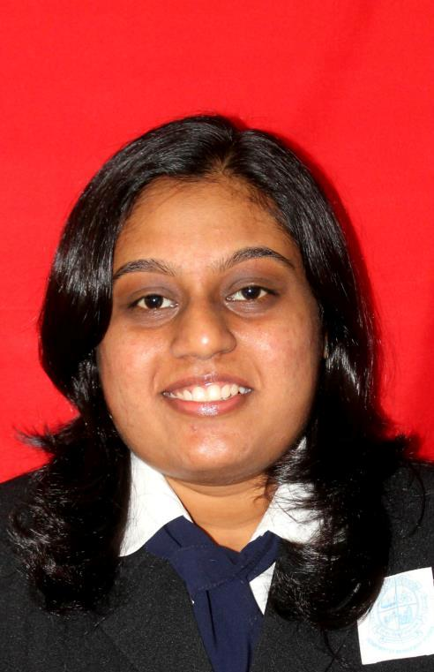
Address: F/3, Feira Alta Apartments, Altinho Mapusa - Goa
(91)- (0832)-2254667(Res): (91)-7507478444(Mob)
Email ID: kim_alvares@rediffmail.com

Career Objective:

To pursue a career in the field of Human Resource in an organization that offers a challenging working environment with opportunity & growth that would best fit my qualification and enable me to grow professionally and personally and gain valuable experience while meeting the organization’s goals.

Current Position:

Assistant Manager – Human Resources at:

G4S Secure Solutions (India) Pvt. Ltd.

Major Job Responsibilities:
- Handling the entire South Branch (1200 employees)
- Payroll
- Maintaining Statutory documents required by Clients.
- Clearing Labour Inspections .
- Handling Resignations and PF withdrawals
- Labour Compliances. (submission of Muster Roll, Wages Register, Wages slip, Monthly Challan, Attendances Card and all other statutory documents.)
- Monitoring man power requirements on a daily basis.
- Employee Muster Updating in ERP.

Educational Details:

QUALIFICATION | YEAR | SCHOOL/COLLEGE  BOARD/UNIVERSITY
MBA | 2011-2013 | Goa University
BBA | 2008-2011 | St. Xaviers College, Mapusa- Goa
HSSC | 2007-08 | St. Xaviers HSS
SSC | 2005-06 | St. Mary’s High School  Mapusa-Goa

Internship Experience:

- April 2013 – 6 week internship at IFB Industries Limited – Verna. (Training, Competency Mapping, Succession Planning, Handling the companies Intranet )

- May 2012 – 8 week internship Tulip Diagnostics (Human Resource Department – Employee Satisfaction).

- May 2010 – 8 weeks internship at Prainha Resort(Human Resource, Front office, Reception, Finance, Stores).

- May 2009 – 6 weeks internship at Tulip Diagnostics (Human Resource/ Administration).

- Was the HR coordinator and a part of the organising committee for ‘ENIGMA’ an all Goa management event organised by St. Xavier’s College Mapusa.

- Was part of the organizing committee of ISSWOV (International Society for the Study of Work and Organizational Values) an international conference organized by Goa University.

Strengths

- Pleasing & Trustworthy personality

- Quick Learner

- Willing to learn new methods of working

- Adaptable to any environment

- Comfortable communicating with people from diverse backgrounds, occupations and cultures

- Ability to perform well under pressure

- Patience

Computer Skills

- Conversant with Microsoft Office.
- Typing speed 45 ~ 50 words per minute.
- Done a course in Photoshop.
- Diploma in Web page designing.

Other Achievements:

- Runner up for a State Management Event (2009-2010).
- Won 1st place for inter college Table Tennis in 2006, 2008, 2010, 2013.
- Runners up in Table Tennis inter College in 2009.
- Won 1st place for inter-college Badminton in 2013.

Extra-Curricular Activities:

Sports 3. Playing the keyboard

Reading 4. Listening to music

Personal details:

Date of Birth | : | 14th October 1990
Marital status | : | Single
Nationality | : | Indian
Languages known | : | English, Hindi, Konkani and French

References:

Mr. Suman Roy  Training Head  IFB Industries Limited  Verna Electronic City  Verna Goa | 9325639278
Dr. R Nirmala  Asst. Professor (HR & OB)  Goa University  Department of Management Studies  Taliegao Plateau  Goa | 9923000060
Mr. Rajesh Narayanan  Branch Manager  G4S Secure Solutions (India) Pvt. Ltd.  Verna Goa | 7506036992
Mr. Anthony Rozario  GeneralManager  G4S Secure Solutions (India) Pvt. Ltd.  Porvoriim - Goa | 8007779533

